Walkthrough 4 XML Views

https://sapui5.hana.ondemand.com/#/topic/1409791afe4747319a3b23a1e2fc7064

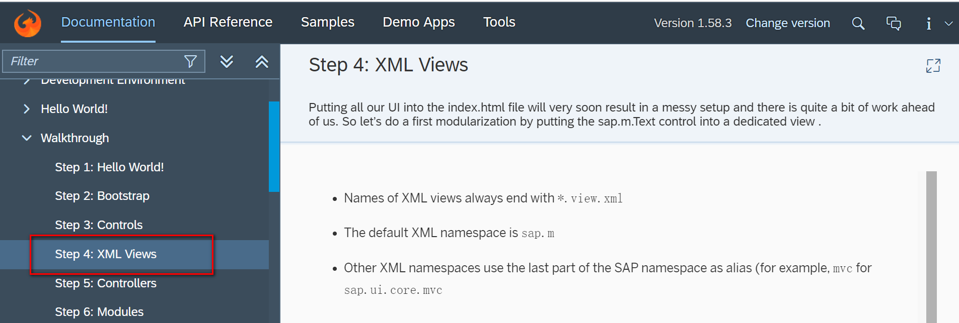

Git:

Result:

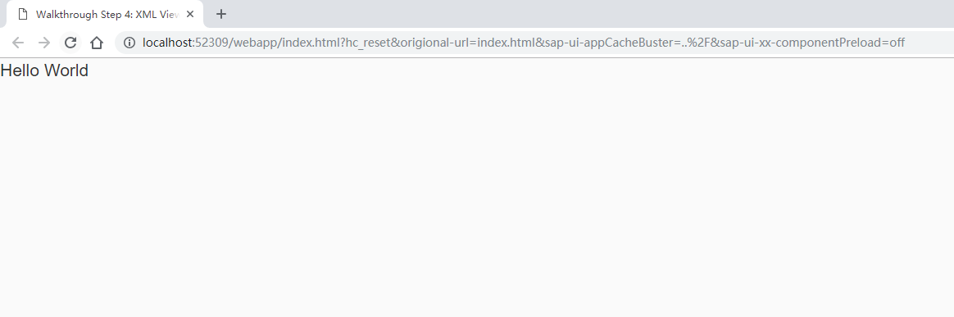

2018/11/01 XiaoMi Beijing Zac,Xie